**Walking Machine 2016 Team Description**

Louis-Martin Caron, Samuel Otis, Jonathan Fortin, Alexandre Doyle, Jeffrey Cousineau,

Xavier Haché, Cassandra Lépine, Alexandre Chartrand, Thierry Pouplier, Jérôme Combet-Blanc, Raphael Lemay and Jimmy Poirier

École de Technologie Supérieure

1100 Rue Notre-Dame O, Montréal, QC H3C 1K3

[walkingmachine@gmail.com](mailto:walkingmachine@gmail.com)

<http://wm.etsmtl.ca/?lang=en>

**Abstract.** This paper gives details about the RoboCup@Home league team Walking Machine, from ETS University in Montreal, Canada for the next competition in Leipzig, Germany, in July 2016. The robot from Walking Machine, named SARA for Système d’Assistance Robotique Autonome (in English, Automated Robotic Assistance System), is a robot entirely built by the student scientific club from ETS. The robot is used for flexible interaction with humans, navigation and mobile object manipulation. This document shows the electrical and mechanical properties and functionalities of SARA. It specifically emphasises on human following, object and people recognition as well as navigation, manipulation and human-robot interaction.

# Introduction

Walking Machine’s team is a young team from Montreal, Quebec, in Canada. We have been preparing our robot for the last year in prevision of the Robocup@home. Our team qualified with our robot, SARA, in the innovative design competition of Quebec Engineering Competition (CQI 2016, Polytechnic University, Montreal, Canada). The team went in many competitions in the past like the Eurobot, but made the leap for the RoboCup in the last years.

SARA, our creation, was designed for polyvalent human-robot interaction as well as efficient navigation and object manipulation. SARA is mounted on four mecanum wheels powered by Roboteq drives, has one arm mimicking a normal human arm, and sensors for communication and navigation. Our team has developed knowledge in object and people detection/recognition, as well as navigation using a laser scanner, odometry on the wheels and a XTION camera. All of these parts are interfaced through the Robot Operating System (ROS).

The next section will discuss the hardware design of SARA. Perceptions and decision making will be respectively shown in sections 3 and 4.

# Electrical and mechanical design of SARA

## 2.1 Electrical

The electrical design was mostly done using pre-built electrical assets. For example, we use Roboteq drives to power Maxon motors. The robot can run at more than 1 m/s in automatic navigation mode. The feedback of the motor speed is done with precise optical encoders and the drive control the motor speed with a PID algorithm.

The arm of our robot has five DOF (Degree Of Freedom). The motors used are the same as the JACO arm model from Kinova. The arm, once fixed to SARA’s frame, can lift up to 2kgs at full extension. Each motor is linked in series and receives its power from the one before. The arm is controlled by a JACO arm base, which distributes commands to the motors to move them.

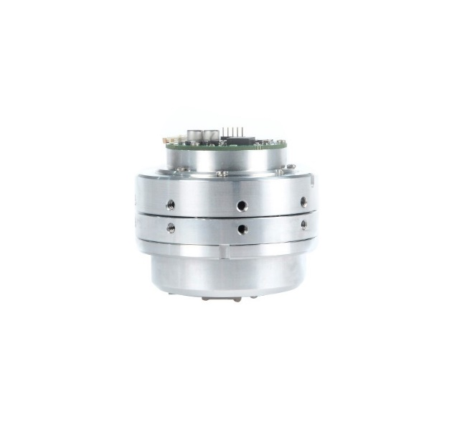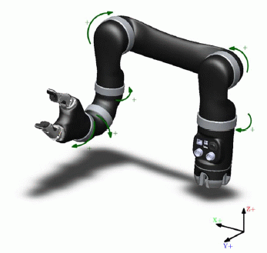

Figure 1 : Kinova arm controller

Figure 2 : Kinova motor

SARA uses lithium-ion power cells with built-in voltage balancing. Each cell has a nominal voltage of 4.2 volts and, once linked together, offers a supply of 25.2 volts to the robot systems. The health of the battery system is monitored with a BMS (Battery Monitoring System) developed by our team. An emergency stop is linked directly to the battery to cut any power if something should go bad. Moreover, a motion stop is being developed to stop the robot during any dangerous action. For the moment, the robot also uses an 120V inverter to supply conventional systems used on the robot, such as the laser sensor or the computer used.

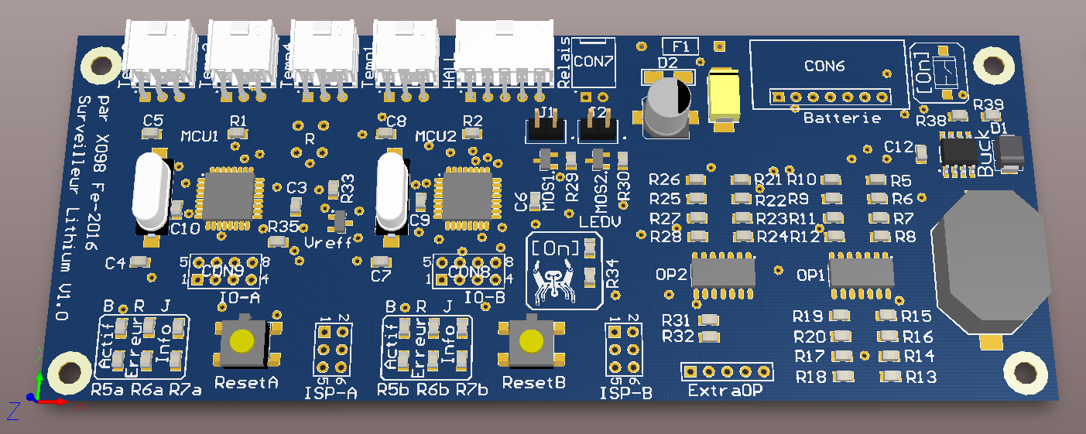

Figure 3 : Battery Management System

The robot uses sensors like a laser sensor for 2D mapping and leg tracking as well as Xtion camera for body tracking. The camera also provides depth perception to recognize objects and faces.

The face of the robot was developed by the team and uses Neopixel RGB LEDs to provide a range of possible emotions and is also linked to voice, so the LEDs will modulate the opening of the mouth with the voice of SARA when she is talking.

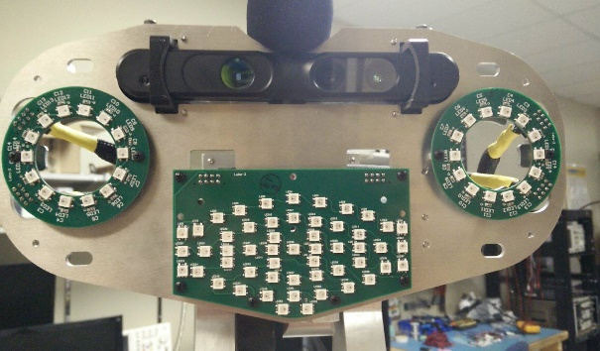

Figure 4 : SARA's face

## 2.2 Mechanical

The general design of the robot is made of a ground base, a trunk, a robotic arm and the head which include a motion sensor, a microphone and a DEL face matrix. The basic frame is assembled with aluminum sheet metal. The shells are made from prototyping plastics, and also with acrylic sheets. Although the aluminum is a light weight metal, the robot is relatively weighty because of the PC case and the Li-Ion battery. Weight reduction will be one of the next improvements after the 2016th edition of the competition Robocup@Home.

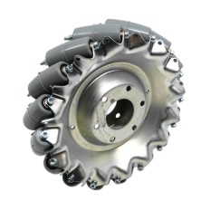One of the principal interests of the robot is its omni-directional wheels. The 45° angle of each roller on the wheel allows frontal displacements as well as lateral movements. The only thing we control are the angular speed and the rotational direction of all the DC motors connected to each wheel.

Figure 5. Mecanum wheel

An innovation is also made on this robot with the titanium printed arm. Considering the high power of the arm actuators, a decision has been taken to use a high performance factor metal to lift the biggest load as possible without any break. Moreover, this metal should be printed to make the fabrication easier. This arm was entirely designed with finite elements method to optimize the resistance and ensure required stiffness, as it is possible to see in figure 2.

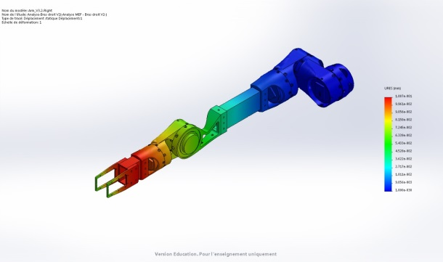

Figure 6. Finite elements analysis of the arm

# Environment perception

## 3.1 Navigation

Most of the software development is toward the movements of the robot in its environment. For this, SARA can build a 2D map using a laser scanner. Using the simultaneous localization and mapping (SLAM) method she can build a 2D map while exploring it and simultaneously know where she is in using the odometry on her wheels, the inertial measurement unit (IMU).

The SOKUIKI laser sensor from Hokuyo can build a 270 degrees, 30 meters map.

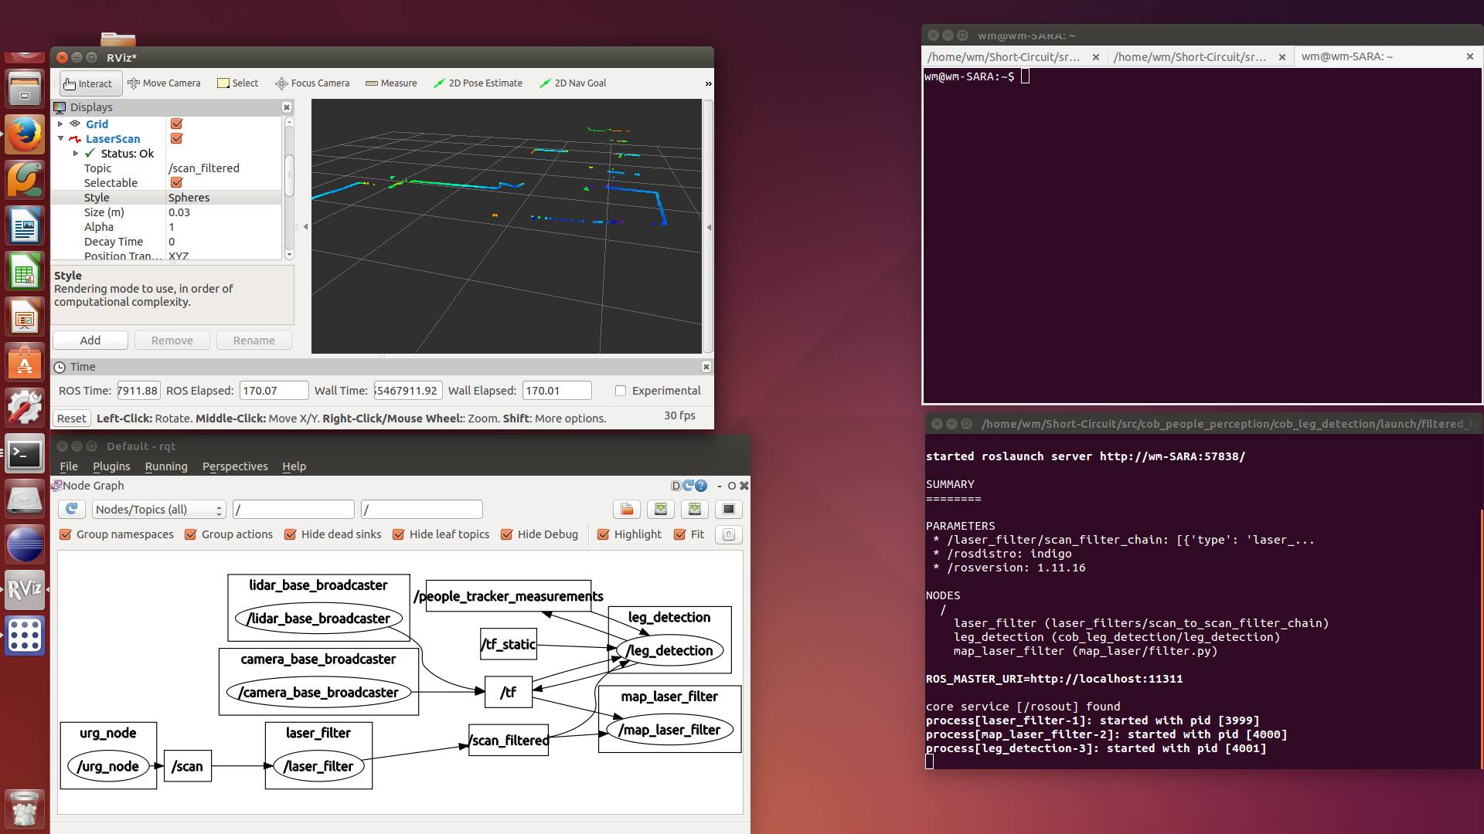

Figure 7 : 2D laser view

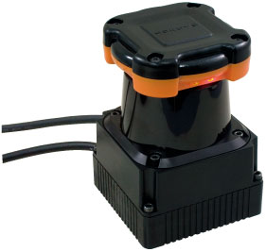

Figure 8 : Laser scanner

Using the sensor, the robot builds a 2D map, which can be saved and then sent to the part of the software responsible of moving the base of the robot. The 2D map updates itself often to be able to react to fast-changing environment, such as an object thrown in front of the robot.

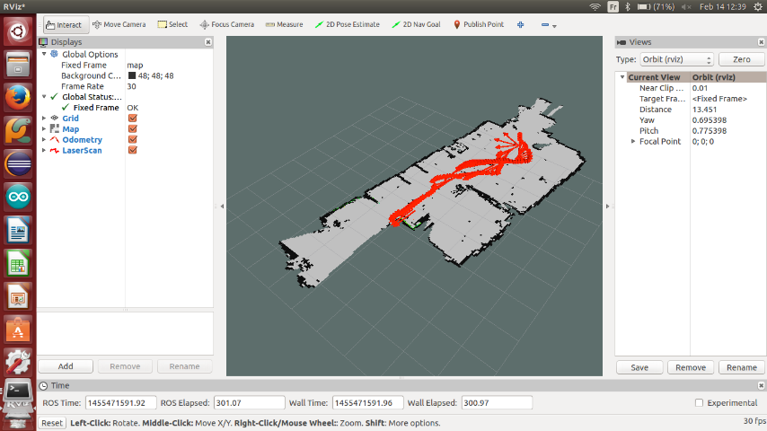

Figure 9 : Mapping

## 3.2 People and objects perception

An RGB/IR Asus Xtion camera is used in parallel with the Hokuyo to build a 3D map of the environment, but at this point we integrated only the 2D mapping and are using the Xtion camera for object and people recognition. Knowing the distances from the base of the robot to the camera, it is possible to use body tracking, which means the robot detects a human body and can analyze it to know where its head, shoulders, hands, legs and feet are. The robot will be able to interpret specific movements using this.

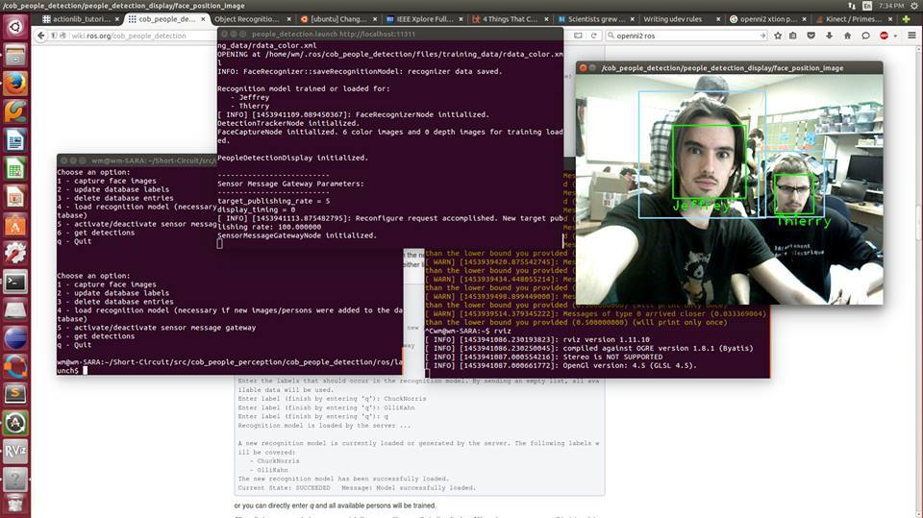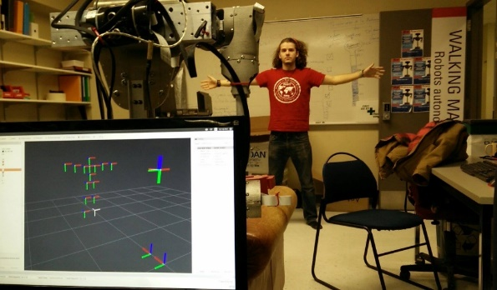

Figure 11 : Face recognition

Figure 10 : Human posture recognition

Face recognition is done through the Xtion. It is possible to add new people via specific services of the software. The face recognition differentiate people through banks of images of the faces and depths of the multiple points. Using statistical analysis, it goes through the bank of images when somebody is presented to the robot and assigns the most reliable face if a match is possible, else the new person is unknown.

# Decision Making

Our high level decision making is made by a hierarchical finite state machine (HFSM). At the highest level, the HFSM wait for an order. Once an order is received, it switches to the corresponding state. It then enters a lower FSM that describe in details all the steps to execute the task.

## 4.1 Navigation

Autonomous navigation uses the Navigation package from ROS [1]. This package is composed of many algorithms that allow a robot to localize itself in a map, plan a trajectory to reach a given target position and compute velocity command. A planar laser scanner and velocity readings are used to build the map. A particle filter tracks the position of the robot as it moves. Velocity commands are computed by the main algorithm and are then sent to the wheels.

## 4.2 Object Manipulation

First of all, a model of the manipulator was created by using the Denavit-Hartenberg [2] parameters. These parameters allow to compute the transform matrix between different reference frames.

Using sensor stream from the stereoscopic camera, the robot is able to locate objects and register their position in its coordinate frame. The object pose becomes the manipulator’s end effector’s target pose.

Inverse kinematics is computed using the Cyclic Coordinate Descent (CCD) method [3]. Starting at the most distal joint and for each joint, this iterative method computes the movement required to minimize the alignment error between the joint pose to effector pose vector and the joint pose to target pose vector. Joint position adjustments are made until the end effector is within tolerance or the maximum number of iterations is reached.

Considering only one joint at time reduces the complexity of the problem while making the algorithm robust against singularities [4].

## 4.3 Human-robot communication

SARA has voice recognition package which branches directly in the decision making part. She has multiple pre-made voice command that she can understand and each of this command will ne to be enabled beforehand by saying her name. Each time SARA hears her name, she will switch in command waiting mode. If the said command is available in her vocal commands tree, she will demand confirmation of it and then proceed on. At any time during an action, she can give details on what she is doing and can be stopped by the safe word STOP. This command overrides every other and acts as a software stop. She uses a voice synthesis package known as pocketsphynx [5] to express herself according to her state.

# Conclusion

As you can see, SARA is a complete autonomous system able of interaction with the human as well as navigation in her environment. She uses multiple sensors, like laser sensor, depth camera, IMU and odometry analyze her environment, recognize people and objects and navigate through obstacles. She can then interact with objects and people using her voice recognition and voice synthesis abilities to keep track of her state. All of the requirements for the Robocup@home are met by SARA and she is a fast-evolving robot considering the team is really young and all undergraduates in engineering programs.

# Robot Hardware Description

Figure 11: SARA robot

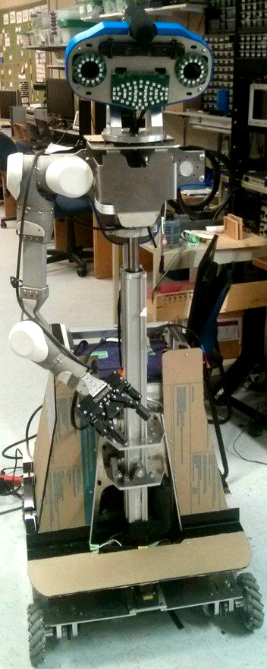Table 1 : Hardware specifications of SARA

|  |  |
| --- | --- |
|  | SARA |
| Name | Système Assistance Robotique Autonome (Autonomous Robotic Assistance System) |
| Base | Custom base with fully holonomic Mecanum wheel platform |
| Motor driver | Roboteq driver |
| Torso | 1 vertical DoF (future implementation) |
| Manipulator | 1 5-DoF custom arm made of Kinova motors |
| Neck | Tilt unit using one Dynamixel MX-64R servo actuator |
| Head | Custom head made of RGB neopixels leds and Asus Xtion Pro |
| Gripper | Robotiq hand 2 fingers 85mm |
| Dimensions | Base : 0,61m X 0,77m Height : 1,68m |
| Weight | 100 kg |
| Additional sensors | Hokuyo UTM-30LX on base |
| Microphone | Rode microphone |
| Batteries | 1x 24V 8 cells Lithium-ion battery |
| Computer | 1x Asus Sabertooth x79 with core i7 and 32 Gb RAM  1x BeagleBone Black with 7” touchscreen 2x Arduino Uno |

# Robot Software Description

|  |  |
| --- | --- |
| Table 2 : Software overview of SARA | |
| Operating system | Ubuntu 14.04 |
| Middleware | ROS Indigo |
| Localization | Gmapping and AMCL |
| SLAM | Gmapping |
| Navigation | DWA local_planner |
| Arm navigation | Moveit and Kinova API |
| Object recognition | Object recognition kitchen |
| Face detection | People face_detector |
| Face recognition | Cob_people_detection |
| Speech recognition | Pocketsphinx |
| Speech synthesis | Espeak |
| Task executors | SMACH |

## Team Members

Walking Machine currently has 12 members, all in undergraduate studies.

Louis-Martin Caron, Samuel Otis, Jonathan Fortin, Alexandre Doyle, Jeffrey Cousineau, Xavier Haché, Cassandra Lépine, Alexandre Chartrand, Thierry Pouplier, Jérôme Combet-Blanc, Raphael Lemay and Jimmy Poirier.

# References

[1] https://github.com/ros-planning/navigation

[2] Denavit, Jacques; Hartenberg, Richard Scheunemann (1955). "A kinematic notation for lower-pair mechanisms based on matrices". *Trans ASME J. Appl. Mech* 23: 215–221.

[3] Wright, Stephen J. (2015). "Coordinate descent algorithms". *Mathematical Programming* 151 (1): 3–34.

# [4] Bruno Siciliano, Oussama Khatib, Springer Handbook of RoboticsSpringer, Science & Business Media, 20 mai 2008 - 1611 pages.

[5] [Francisco Ferrer Sales](https://www.google.ca/search?hl=fr&tbo=p&tbm=bks&q=inauthor:%22Francisco+Ferrer+Sales%22), SLAM and Localization of People with a Mobile Robot using a RGB-D Sensor, University of Coimbra, 1 juil. 2014 - 100 pages